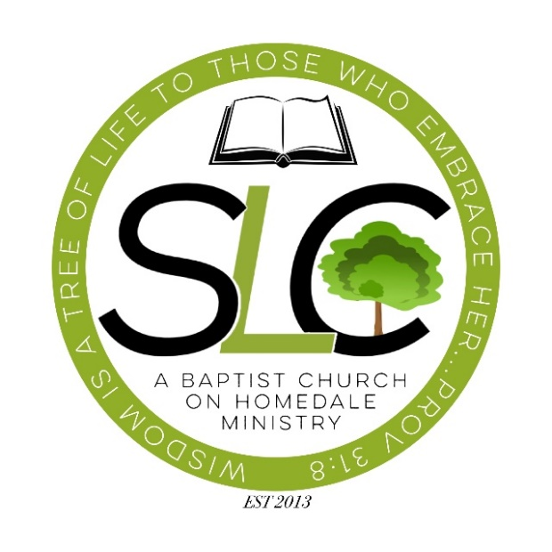
Summer Program
STUDENT LIFE CENTER
Return completed Application to:
Baptist Church on Homedale, attention SLC
3052 Homedale Road, Klamath Falls, OR 97603
Phone: 458-254-0417

Parent/Guardian Name: ______________________________

Parent Phone Number: _______________________________

Parent e-mail: ______________________________________

Parent Address: ______________________________________________________________

Student Name: ___________________________________Student Birthdate: _____________

School: __________________________ Grade: ________

- Which subjects are you interested in receiving help with?

- Please describe any special challenges that the SLC should be made aware of:

- Do you agree to a 15-minute Life Lesson each week?

- Life Lessons encourage conversation regarding positive moral traits and critical life decisions.

- What days would you like to receive tutoring?

Parent/Guardian Signature: _______________________________ Date__________________
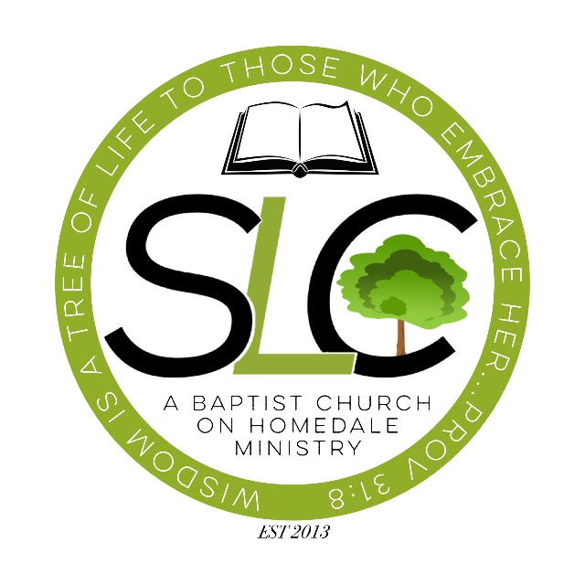
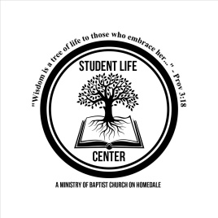

PARENT/GUARDIAN CONSENT

Please review the statements below.
Sign to indicate your compliance and agreement.

- I give my consent to the SLC to teach a weekly Life Lesson. Life Lessons include Bible based teachings on morality and life topics such as: honesty, integrity, responsibility, generosity, kindness, forgiveness, relationships, and (for students from the 7th grade and up) sexual purity.

- I agree to notify the SLC of any changes in my student’s schedule and understand that failure to do so may result in my student losing his/her current enrollment status at the SLC.

Please list any allergies, medical issues or special concerns:

I hereby agree to comply with the statements listed above:

Parent/Guardian Signature: _____________________________________

Parent/Guardian Printed Name: __________________________________

Date: ___________________

Student Name: _______________________________________________

Photography Release
OPTIONAL

By signing this form, you give the Baptist Church on Homedale and all Student Life Center participants and employees permission to use you or your child’s name and image - that we may collect by means of digital or film photography, video, audio recording, or other documentation method – in any combination of our publications, in publicity or advertising, on our website, or in any other print, electronic, or digital medium.
I have read this photography release and acknowledge The Student Life Center’s and Baptist Church on Homedale’s right to use these photographs.

Name of Person in the Photo: __________________________________________
Student Life Center
Baptist Church on Homedale
3052 Homedale Road
Klamath Falls, OR 97603

Signature: _______________________________________________ Date: _________________
(Parent’s Signature if the above named person is under 18)

Printed Name: ___________________________________________

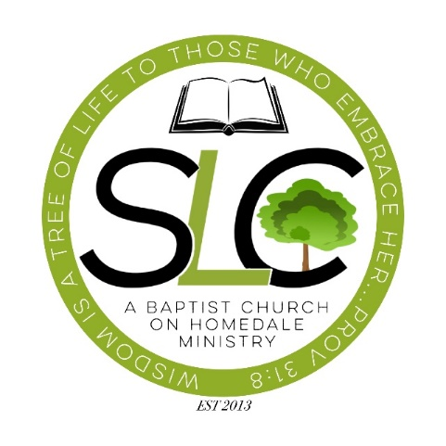

STUDENT LIFE CENTER TIPS FOR SUCCESS

- Students - Be willing to focus and work.

- If you are willing to focus and work consistently, you will succeed.
- If you are not willing to focus and work consistently, you will not succeed.

- Parents and Students - Keep us informed of your schedule.

- An average minimum attendance of 2 days per week during the school year is required.
- Schedules change, so keep us informed.
- Please contact The Student Life Center Phone 458-254-0417.

- Parents and Students - Communicate and Follow Up.

- Communication is critical. Let us know how you are doing in our program and what we can do to provide the best service possible.

- Does your student need a ride?

  - If yes, please indicate your pickup and address and days needed.

- Donations are Needed! How to donate to the Student Life Center:

- Make checks payable to BCH; designate that your gift is for the SLC and give it directly to the SLC Management Staff or drop it in the offering plate or connection box on Sunday. (Giving envelopes are available.)
- Give online anytime at http://www.baptistchurchonhomedale.org/give/
and designate to: SLC.
- Snack donations are appreciated too!

Student Life Center Director
458-254-0417 Business
PLEASE DETACH AND KEEP THIS FORM FOR YOUR REFERENCE

